FITLENS – TEST PLAN & TEST RESULTS

Introduction
FitLens is an AI-powered body measurement system using YOLOv8n segmentation, MediaPipe landmark detection, and pixel-to-scale conversion to compute accurate anthropometric measurements from user-submitted front and side images.

System Overview
Processing Pipeline Steps:
• Preprocessing
• YOLOv8n-Seg Masking
• MediaPipe Landmark Extraction
• Pixel-to-Scale Measurement
• Result Packaging & Display
Actual Front & Side View Images:
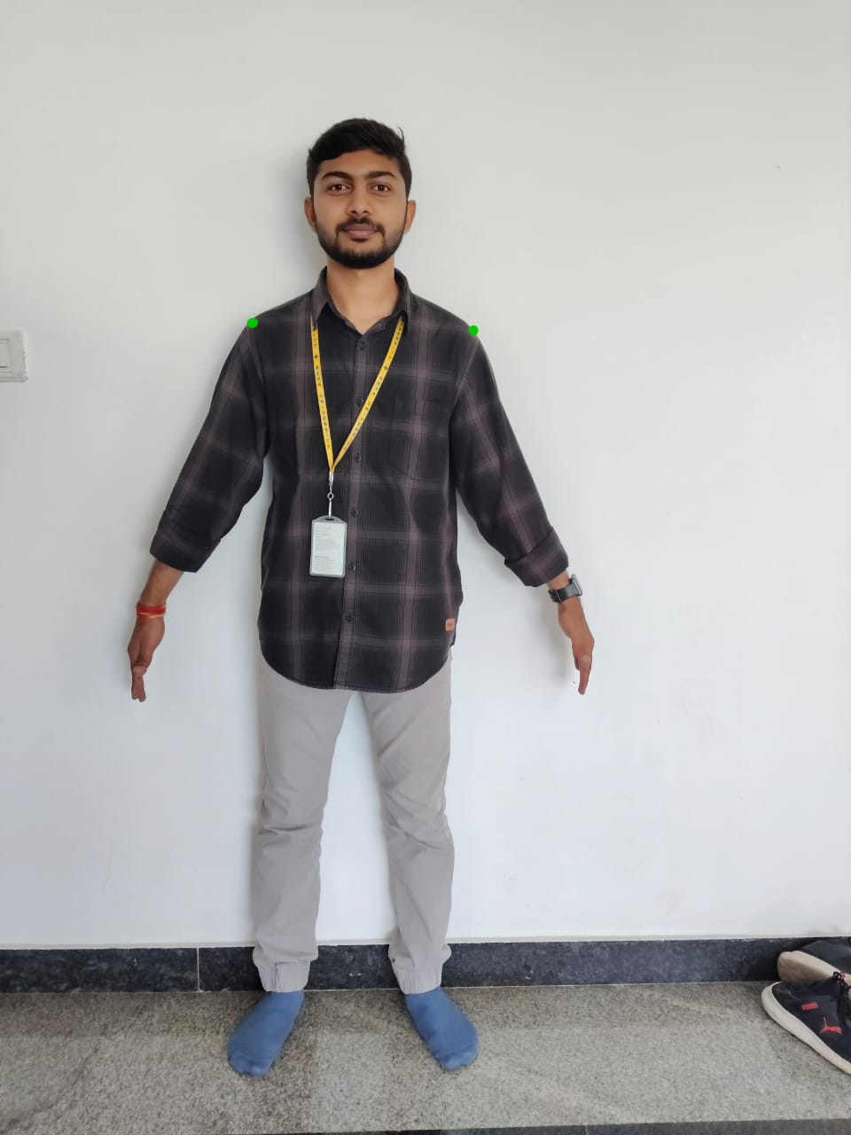 | 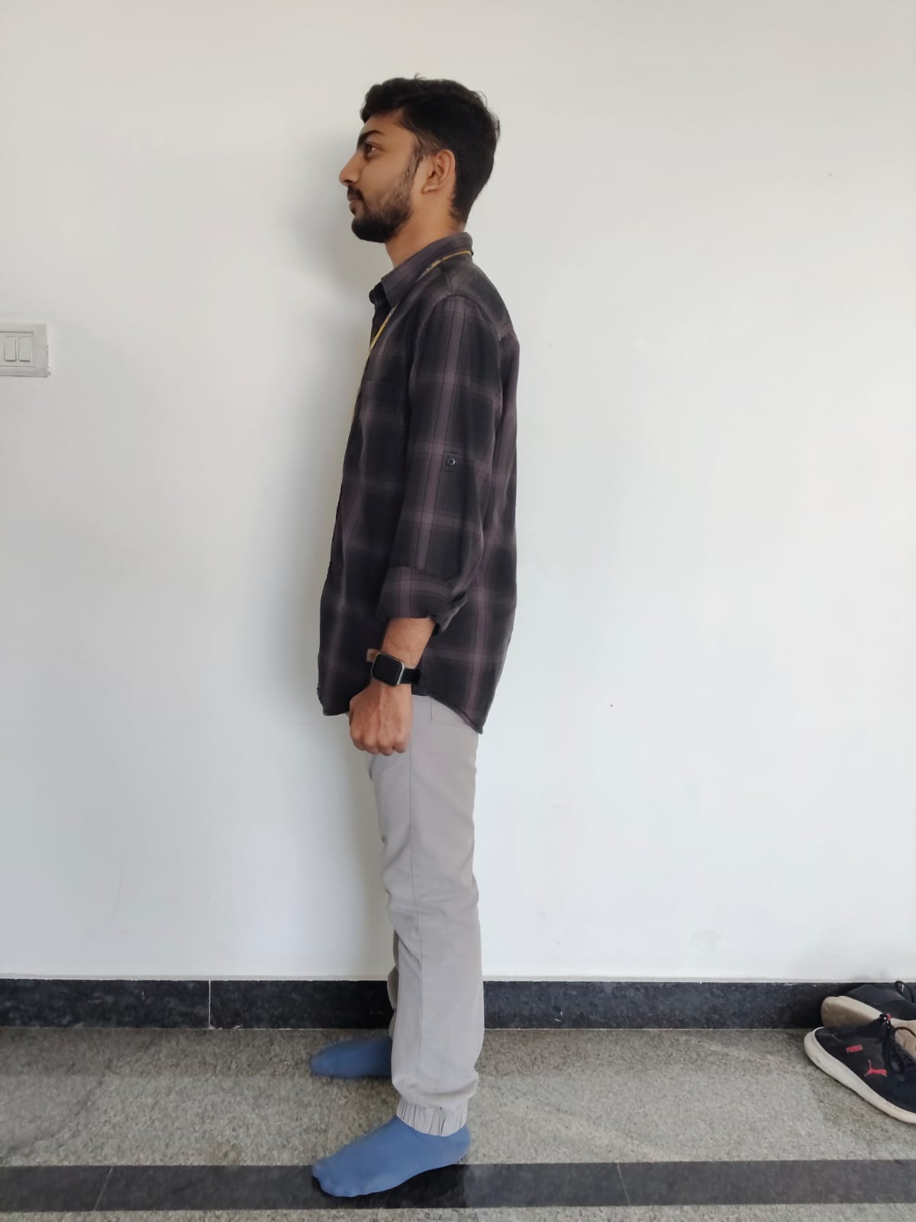

Test Objectives
• Verify functionality of image upload and live camera capture
• Validate the accuracy of measurements (±1–2 cm tolerance)
• Ensure smooth API ↔ Worker ↔ UI interaction
• Confirm performance of the inference pipeline
• Validate database entries: Sessions, Captures, Measurements

Test Scope
✔ In-Scope:
• Front + side image uploads
• Height input validation
• YOLO segmentation accuracy
• MediaPipe landmark placement
• Measurement calculation & JSON generation
• UI visualization of measurements
• Backend storage & retrieval
❌ Out-of-Scope:
• Highly irregular poses
• Extreme lighting conditions
• Full mobile/browser compatibility grid

Test Types Covered
Test Type | Description
Functional | Verifies all app features
Integration | Backend–Worker–DB–UI communication
Performance | Pipeline speed & memory usage
Accuracy | Measurement correctness
Negative Testing | Edge cases & invalid inputs
Usability | UI clarity & responsiveness

Test Cases

Upload & Camera Flow
Steps | Expected Result | Status
Upload front & side images | Images stored in S3 + DB updated | Pass

Segmentation & Landmark Detection
Expected Output | Actual Result | Status
Clean segmentation mask | Generated correctly | Pass
Accurate landmark placement | Detected accurately | Pass

Pixel-to-Scale Conversion
Expected | Actual | Status
Correct height normalization | Accurate conversion | Pass

UI Display Verification
• Measurement table displays Waist, Hip, Shoulder, Chest, Inseam
• Landmark overlay visible
• JSON stored correctly
Status: Pass

Performance Test Results
Test | Expected | Actual | Status
YOLO Segmentation | < 2 sec | 1.3 sec | Pass
Landmark Detection | < 1 sec | 0.7 sec | Pass
Total Processing | < 5 sec | 3.2 sec | Pass

Accuracy Test Results
Body Part | Manual Tape | FitLens Output | Difference | Status
Waist | 74 cm | 75.1 cm | +1.1 cm | Pass
Hip | 95 cm | 96.3 cm | +1.3 cm | Pass
Shoulder Width | 42 cm | 41.2 cm | -0.8 cm | Pass
Inseam | 80 cm | 79.1 cm | -0.9 cm | Pass

Negative Test Cases
Case | Expected | Actual | Status
Non-human image | Error message | Shown correctly | Pass
Only one image uploaded | 'Front & Side required' | Shown | Pass
Missing height | 'Height is required' | Shown | Pass

Test Summary
Category | Tests | Passed | Failed
Functional | 12 | 12 | 0
Integration | 6 | 6 | 0
Accuracy | 4 | 4 | 0
Performance | 3 | 3 | 0
UI/UX | 3 | 3 | 0
Overall Result: FitLens MVP is stable, accurate & ready for deployment.

Conclusion
The FitLens system meets all test criteria:
✔ Reliable processing pipeline
✔ Accurate body measurements
✔ Smooth UI flow
✔ Strong error handling
FitLens is fully ready for MVP demonstration and deployment.

